1. **Wilson Problem**: Wilson Manufacturing produces both baseballs and softballs, which it wholesales to vendors around the country. Its facilities permit the manufacture of a maximum of 500 dozen baseballs and a maximum of 500 dozen softballs each day. The cowhide covers for each ball are cut from the same processed cowhide sheets. Each dozen baseballs require five square feet of cowhide (including waste), whereas, one dozen softballs require six square feet of cowhide (including waste). Wilson has 3600 square feet of cowhide sheets available each day. Production of baseballs and softballs includes making the inside core, cutting and sewing the cover, and packaging. It takes about one minute to manufacture a dozen baseballs and two minutes to manufacture a dozen softballs. A total of 960 minutes is available for production daily. The prices for a dozen baseball and a dozen softball are 7 and 10 dollars respectively.

Answer the following:

a) Formulate the problem in the Excel file and generate the sensitivity analysis.

b) Write on cost coefficient sensitivity analysis.

c) Write on Right Hand Side Sensitivity Analysis. (5+7+8=20 Marks)

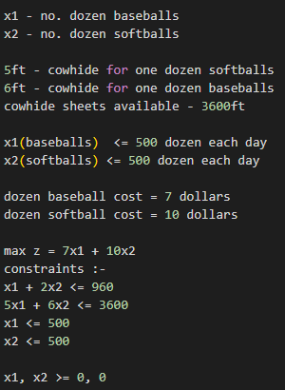Ans) a)

After finding the solution :-

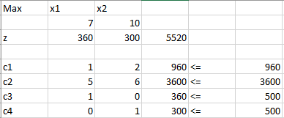

Sensitivity report: 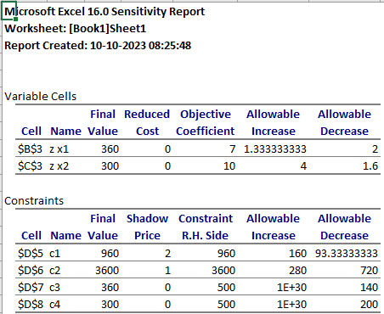-

b) Report on cost coefficient sensitivity analysis :-

As we have earlier mentioned x1 indicates the no. of dozens of baseballs, and x2 indicates the no. of dozens of softballs, from the sensitivity report we get that no. of dozens of baseballs that could be produced such that we get the best profit is 360, and we could produce 300 softballs per day with the given constraints and providing the maximum profit.

We can infer from the cost coefficient that x1 i.e the cost coefficient of baseballs per dozen could be increased till 1.33(aprrox.) and can be decreased till 2 dollars.

Similarly the cost of softballs per dozen could be increased till 4 dollars and reduced till 1.6 dollars, till which the solution obtained remains optimal.

c) Report on Right Hand Side Sensitivity analysis :-

We can see that the right hand side constraints can have lot of changes, going one by one :-

1. The first constraint analysis shows that the resource is completely used, and could be increased till 160 and could be decreased till 93.33(approx..), Shadow price tells that any change made to the constraint would effect two units of it.
2. The second constraint analysis shows that the resource is completely used, and could be increased till 280 and could be decreased till 720, Shadow price tells that any change made to the constraint would effect one unit of it.
3. The third constraint analysis shows that the company was unable to manufacture 500 baseballs per day, and could decrease it’s manufacturing by 140 or could increase it by 1E+30, and there is no effect of it’s shadow price.
4. The fourth constraint analysis shows that the company was unable to manufacture 500 softballs per day, and could decrease it’s manufacturing by 200 or could increase it by 1E+30, and there is no effect of it’s shadow price.

2. Consider the following problem:

𝑓(𝑥1, 𝑥2 ) = 4𝑥1 + 6𝑥2 − 2𝑥1 2 − 2𝑥1𝑥2 − 2𝑥2 2

1. Write a program to visualize the above function.
2. Write an iterative program to maximize the function.

(5+5 = 10 Marks)

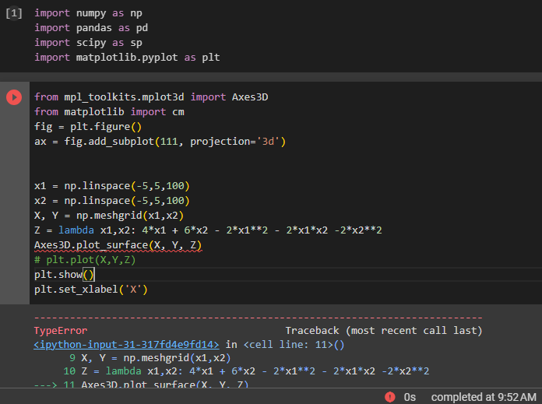Ans)